Part 1 (BER Graph)

Part 2 (Samples of all data)

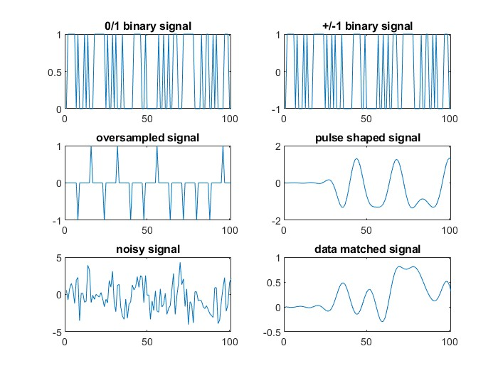

Part 3 (Sampled Points 50-150)

Oversampled

Pulse Shaped

Noisy Signal

Data after Receive

Code (W/ Changes)

% Program 3-1

% bpsk.m

%

% Simulation program to realize BPSK transmission system

%

% Programmed by H.Harada and T.Yamamura,

%

%\*\*\*\*\*\*\*\*\*\*\*\*\*\*\*\*\*\*\*\* Preparation part \*\*\*\*\*\*\*\*\*\*\*\*\*\*\*\*\*\*\*\*\*\*

sr=256000.0; % Symbol rate

ml=1; % Number of modulation levels

br=sr.\*ml; % Bit rate (=symbol rate in this case)

nd = 1000; % Number of symbols that simulates in each loop

IPOINT=8; % Number of oversamples

%\*\*\*\*\*\*\*\*\*\*\*\*\*\*\*\*\*\*\* Filter initialization \*\*\*\*\*\*\*\*\*\*\*\*\*\*\*\*\*\*\*\*

irfn=21; % Number of filter taps

alfs=0.5; % Rolloff factor

[xh] = hrollfcoef(irfn,IPOINT,sr,alfs,1); %Transmitter filter coefficients

[xh2] = hrollfcoef(irfn,IPOINT,sr,alfs,0); %Receiver filter coefficients

%\*\*\*\*\*\*\*\*\*\*\*\*\*\*\*\*\*\*\*\* START CALCULATION \*\*\*\*\*\*\*\*\*\*\*\*\*\*\*\*\*\*\*\*\*

nloop=100; % Number of simulation loops

noe = 0; % Number of error data

nod = 0; % Number of transmitted data

for ebn0=0:10

for iii=1:nloop

%\*\*\*\*\*\*\*\*\*\*\*\*\*\*\*\*\*\*\*\* Data generation \*\*\*\*\*\*\*\*\*\*\*\*\*\*\*\*\*\*\*\*\*\*\*\*\*\*\*\*\*\*\*\*

data=rand(1,nd)>0.5; % rand: built in function

%\*\*\*\*\*\*\*\*\*\*\*\*\*\*\*\*\*\*\*\* BPSK Modulation \*\*\*\*\*\*\*\*\*\*\*\*\*\*\*\*\*\*\*\*\*\*\*

data1=data.\*2-1;

[data2] = oversamp( data1, nd , IPOINT) ;

data3 = conv(data2,xh); % conv: built in function

%\*\*\*\*\*\*\*\*\*\*\*\*\*\*\*\*\*\* Attenuation Calculation \*\*\*\*\*\*\*\*\*\*\*\*\*\*\*\*\*

spow=sum(data3.\*data3)/nd;

attn=0.5\*spow\*sr/br\*10.^(-ebn0/10);

attn=sqrt(attn);

%\*\*\*\*\*\*\*\*\*\*\*\*\*\*\*\*\*\*\*\*\*\* Fading channel \*\*\*\*\*\*\*\*\*\*\*\*\*\*\*\*\*\*\*\*\*\*

% Generated data are fed into a fading simulator

% In the case of BPSK, only Ich data are fed into fading counter

% [ifade,qfade]=sefade(data3,zeros(1,length(data3)),itau,dlvl,th1,n0,itnd1,now1,length(data3),tstp,fd,flat);

% Updata fading counter

%itnd1 = itnd1+ itnd0;

%\*\*\*\*\*\*\*\*\*\*\*\* Add White Gaussian Noise (AWGN) \*\*\*\*\*\*\*\*\*\*\*\*\*\*\*

inoise=randn(1,length(data3)).\*attn; % randn: built in function

data4=data3+inoise;

data5=conv(data4,xh2); % conv: built in function

sampl=irfn\*IPOINT+1;

data6 = data5(sampl:8:8\*nd+sampl-1);

%\*\*\*\*\*\*\*\*\*\*\*\*\*\*\*\*\*\*\*\* BPSK Demodulation \*\*\*\*\*\*\*\*\*\*\*\*\*\*\*\*\*\*\*\*\*

demodata=data6 > 0;

%\*\*\*\*\*\*\*\*\*\*\*\*\*\*\*\*\*\*\*\* Bit Error Rate (BER) \*\*\*\*\*\*\*\*\*\*\*\*\*\*\*\*\*\*

noe2=sum(abs(data-demodata)); % sum: built in function

nod2=length(data); % length: built in function

noe=noe+noe2;

nod=nod+nod2;

fprintf('%d\t%e\n',iii,noe2/nod2);

end % for iii=1:nloop

%\*\*\*\*\*\*\*\*\*\*\*\*\*\*\*\*\*\*\*\*\*\*\* Plot data (Part 2) \*\*\*\*\*\*\*\*\*\*\*\*\*\*\*\*\*\*\*\*\*\*\*\*\*\*

figure

subplot(3, 2, 1)

plot(data(50:150))

title('0/1 binary signal')

subplot(3, 2, 2)

plot(data1(50:150))

title('+/-1 binary signal')

subplot(3, 2, 3)

plot(data2(50:150))

title('oversampled signal')

subplot(3, 2, 4)

plot(data3(50:150))

title('pulse shaped signal')

subplot(3, 2, 5)

plot(data4(50:150))

title('noisy signal')

subplot(3, 2, 6)

plot(data5(50:150))

title('data matched signal')

%\*\*\*\*\*\*\*\*\*\*\*\*\*\*\*\*\*\*\*\*\*\*\* Plot data (Part 3) \*\*\*\*\*\*\*\*\*\*\*\*\*\*\*\*\*\*\*\*\*\*\*\*\*\*

figure

plotspec(data2(50:150))

figure

plotspec(data3(50:150))

figure

plotspec(data4(50:150))

figure

plotspec(data5(50:150))

%\*\*\*\*\*\*\*\*\*\*\*\*\*\*\*\*\*\*\*\*\*\* Output result \*\*\*\*\*\*\*\*\*\*\*\*\*\*\*\*\*\*\*\*\*\*\*\*\*\*\*

ber(ebn0+1) = noe/nod;

fprintf('%d\t%d\t%d\t%e\n',ebn0,noe,nod,noe/nod);

fid = fopen('BERbpsk.dat','a');

fprintf(fid,'%d\t%e\t%f\t%f\t\n',ebn0,noe/nod,noe,nod);

fclose(fid);

end

figure

semilogy(0:10,ber)

%\*\*\*\*\*\*\*\*\*\*\*\*\*\*\*\*\*\*\*\* end of file \*\*\*\*\*\*\*\*\*\*\*\*\*\*\*\*\*\*\*\*\*\*\*\*\*\*\*